HW3

Mira Jamous 11926792

1. I created a binary tree that has 10 as the root, as shown below

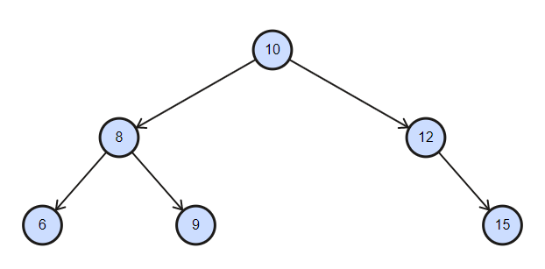

1. 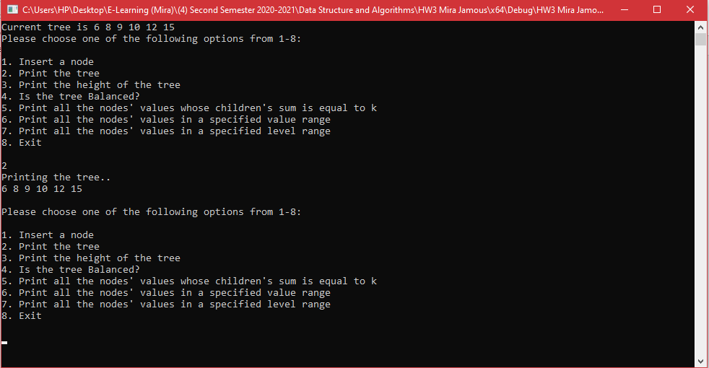Here you can see that when I choose 2, it will print the tree in LVR order
2. 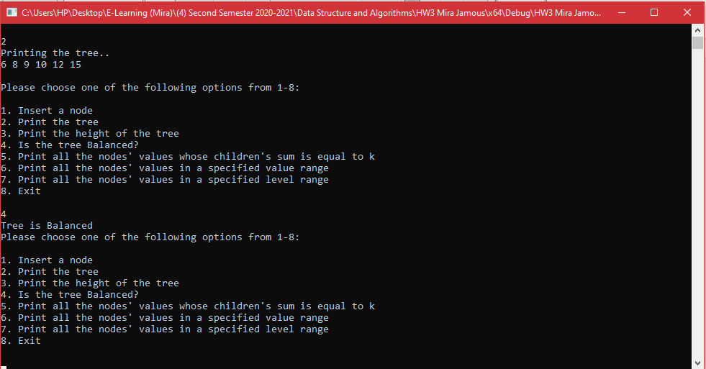When we test the balance function it should say that the tree is balanced because each node in the current tree has a balance factor of 0 or 1. The tree is balanced as you can see
3. 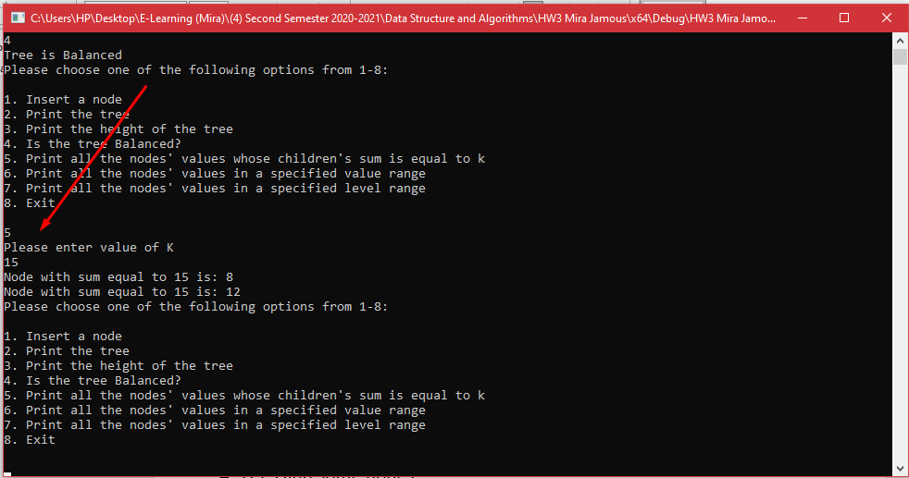Now I will test the function that finds the nodes whose children's sum is equal to k. I used k=15 as a test, it should print 8 and 12 since their children have a sum of 15. And it works.

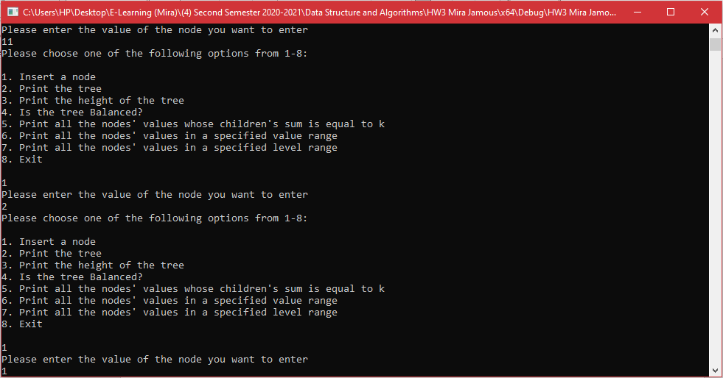5.Let's add some nodes. The nodes added are 1,2,11.

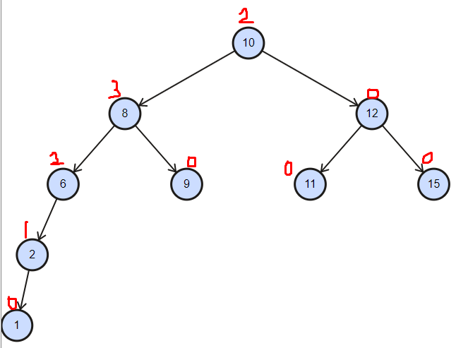The tree looks like this now:

5.The tree now is unbalanced because as you can see in step 4 , the nodes 6,8, and 10 have a balance factor which is bigger than 1 therefore the tree is unbalanced. As you can see on the command screen, the tree is unbalanced

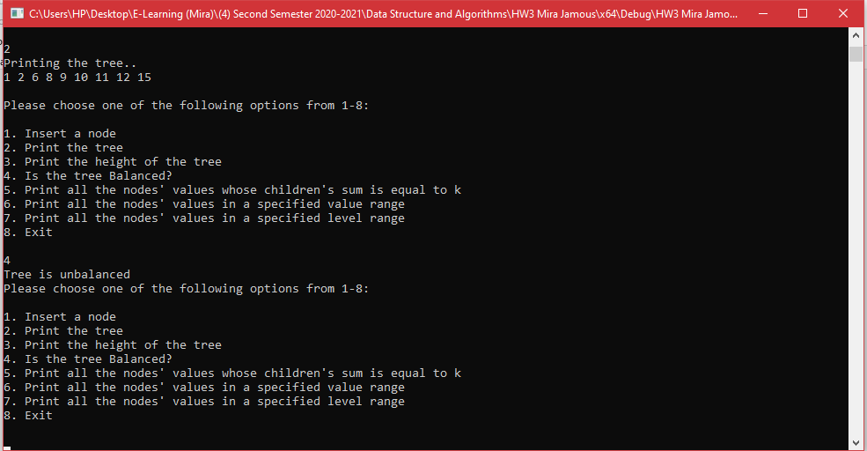

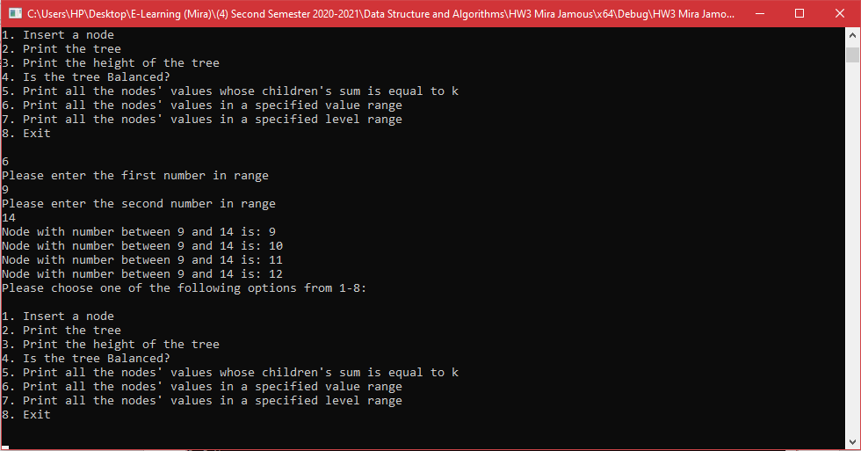6.Let's see the nodes which have values in a specified range. Here the first value is 9 and the second value is 14. The nodes that fall in the range are 9,10,11,12,14. As you can see the command screen shows exactly what we expect.

7. Let's repeat step 6 but the range is levels.

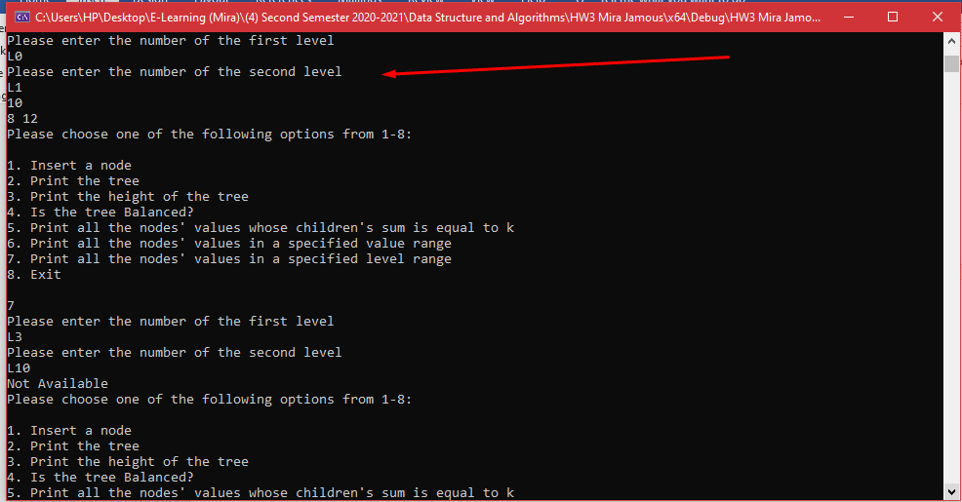 a. First we'll see what nodes fall between Level0 and Level1. We got the expected result which is 10,8,12

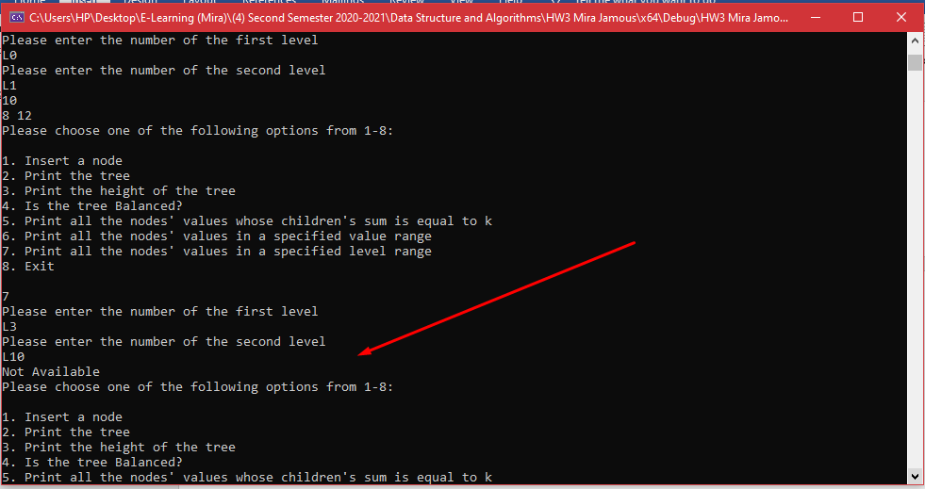 b. Then we'll see what nodes fall between Level3 and Level10. It show not available because Level 10 doesn't exist